Characteristic Curves of Silicon Nanowire Surrounding Gate Field Effect Transistors
Muhammad Aldacher
Department of Electrical Engineering, San Jose State University
San Jose, CA – 95112
muhammad.aldacher@sjsu.edu

Abstract—The main purpose of this assignment is to develop an understanding for the basic tools used in the Cadence Virtuoso Analog-Design Environment (ADE) essential for designing & analyzing any analog circuit. In addition to that, the characteristics of the NMOS & PMOS transistors in the novel technology of the 10nm silicon nanowire surrounding gate field effect transistor (SGFET) are studied for future use in the design of larger integrated circuits.

Index Terms— Cadence virtuoso, I-V curves, SGFET, Field-effect transistors

INTRODUCTION
THE behavior of transistors differ from one technology to another, so it is essential to study the characteristics of the technology being used before employing it in designing integrated circuits. One way to do that is by observing the IV curves of the transistors which explain how the drain current, I_{D}, behaves as the terminal voltages change.^{[1]}
In this assignment, a novel technology, namely the “silicon nanowire SGFET”, is studied. The intrinsic part of the transistor device in this technology consists mainly of a channel, 10nm in length & 2nm in radius, completely surrounded by the gate. This structure gives full control to the gate on the channel eliminating some crucial short-channel effects like drain-induce barrier lowering (DIBL). This technology shows very promising potential for Analog & RF applications.^{[2]}

Test bench setup
The test bench setups for the NMOS transistor & the PMOS transistor are shown in Fig. 1 & 2, respectively. The gate & drain terminal voltages are swept with respect to the source terminal voltage using DC sources connected to the gate & the drain.

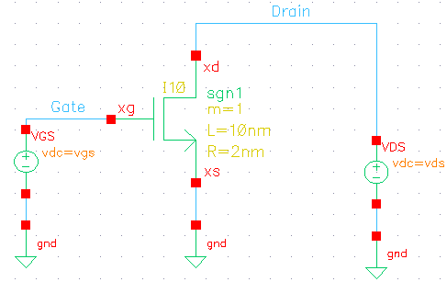
Fig. 1. NMOS transistor test bench setup

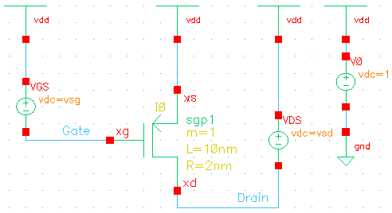
Fig. 2. PMOS transistor test bench setup

DC Analysis & Results

Drain Current while changing Gate Voltage
For the NMOS transistor, to get the I_{D}-V_{GS} curve, the V_{DS} is fixed at a certain value (1V in our setup) while sweeping V_{GS} with an increment of 10mV. In case of the PMOS transistor, the same procedure is conducted with the slight difference of changing the voltage difference polarity, so the I_{D}-V_{SG} is obtained while keeping V_{SD} fixed at 1V. The curves for the NMOS & PMOS transistors are shown in Fig. 3 & 4, respectively.
It is worth to mention that I_{D} increases dramatically after the V_{GS} (or V_{SG} in case of the PMOS) reaches a certain voltage value called the “Threshold voltage” or “V_{TH}”, which is about 0.26V in NMOS & -0.28V in PMOS.

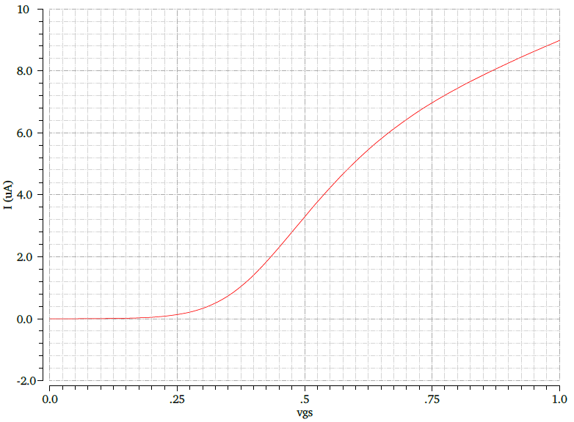
Fig. 3. I_{D}-V_{GS} curve for the NMOS transistor

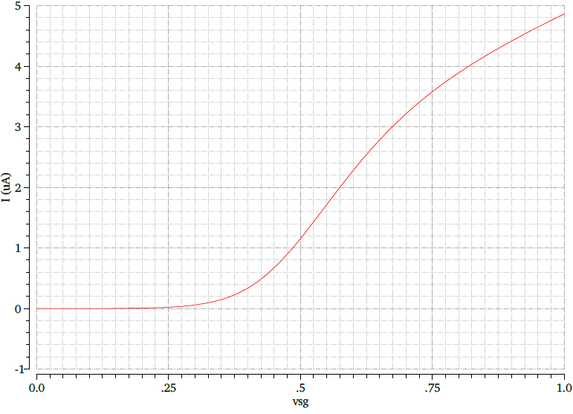
Fig. 4. I_{D}-V_{SG} curve for the PMOS transistor

Drain Current while changing Drain Voltage
To get the I_{D}-V_{DS} curve in the case of the NMOS transistor, the V_{GS} is now kept fixed at a certain value (0.5V in our setup) while sweeping V_{DS} with an increment of 10mV. In case of the PMOS transistor, V_{SG} & V_{SD} are used instead of V_{GS} & V_{DS}, respectively. The output characteristic curves are shown in Fig. 5 & 6.

Output Resistance r_{ds}
The resistance of the MOSFET transistor can be calculated as the inverse of the derivative of the drain current I_{D} with respect to the drain-source voltage V_{DS}. This relationship can be shown in equation (1).

r_{ds} = (1)

The curves for the resistance r_{ds} can be obtained using the calculator function in the ADE while sweeping the value of V_{DS} at a fixed value of V_{GS}. Using the same tool, the second & third derivatives can also be obtained. These curves are shown in Fig. 7(a), (b), & (c) for the NMOS, and Fig. 8(a), (b), & (c) for the PMOS.
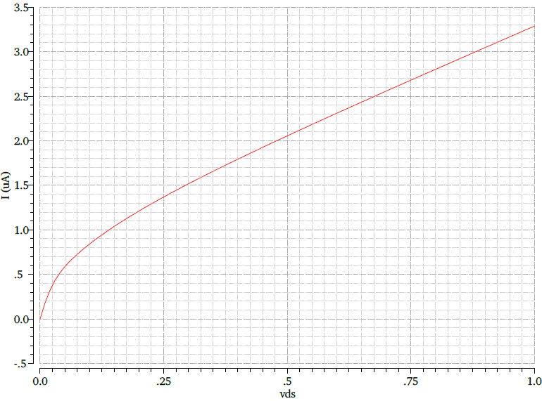
Fig. 5. I_{D}-V_{DS} curve for the NMOS transistor

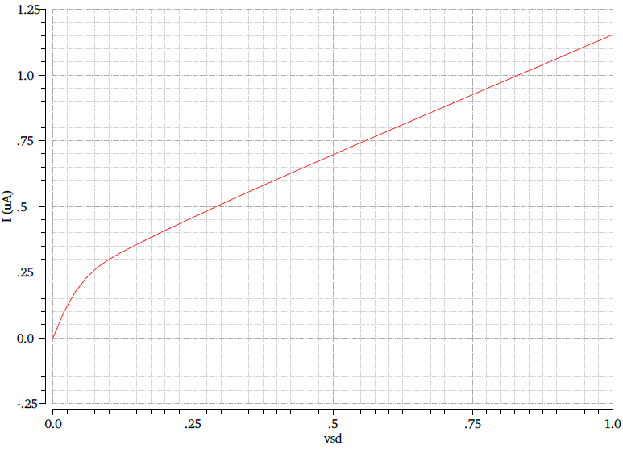
Fig. 6. I_{D}-V_{SD} curve for the PMOS transistor

Transconductance g_{m}
The transconductance of the MOSFET transistor is calculated by taking the derivative of the drain current I_{D} with respect to the gate-source voltage V_{GS} as expressed in equation (2).

g_{m} = (2)

Similar to what was done for r_{ds}, using the calculator function in the ADE while sweeping the value of V_{GS} at a fixed value of V_{DS}, the curve for g_{m}, the second & the third derivatives can be obtained. These curves are shown in Fig. 9(a), (b), & (c) for the NMOS, and Fig. 10(a), (b), & (c) for the PMOS.
It is noticed that g_{m} increases with the increase of V_{GS} till it reaches a peak value, then starts to drop as V_{GS} continues to increase. This is because g_{m} is the slope of the I_{D}-V_{GS} curve, and as shown in Fig. 3 & 4, the increase of I_{D} starts to fall at high values of V_{GS}, as if I_{D} is reaching a saturation point after which the effect of increasing V_{GS} is not as strong. As a result, g_{m} starts to fall after a peak value as V_{GS} further increases.
The maximum g_{m} value for the NMOS transistor is 19.74 uS & it occurs at V_{GS}=488.57mV, while for the PMOS transistor, it is 11.48 uS at V_{SG}=558.15mV.
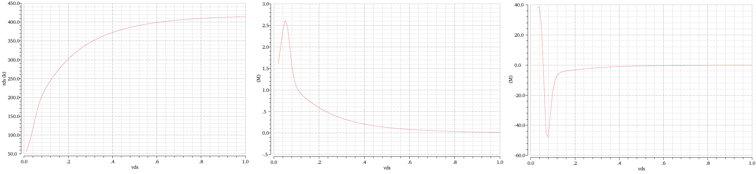
(a) (b) (c)

Fig. 7. (a) r_{ds}, (b) its 2nd derivative, & (c) its 3rd derivative curves for the NMOS transistor

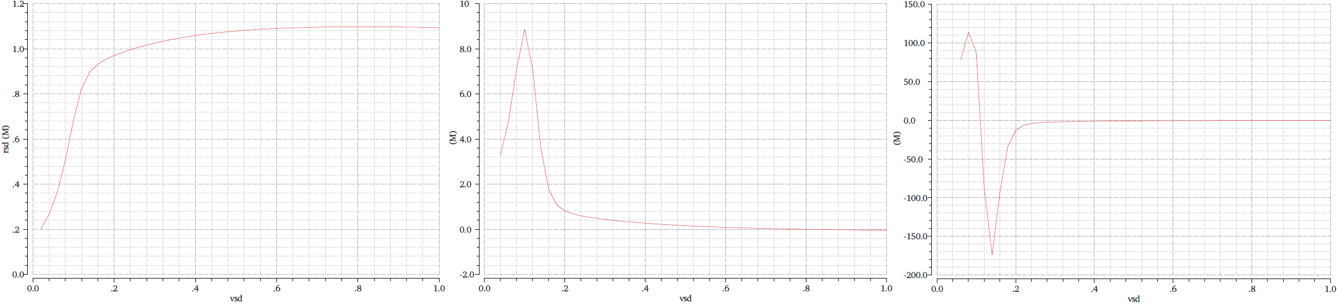
(a) (b) (c)

Fig. 8. (a) r_{sd}, (b) its 2nd derivative, & (c) its 3rd derivative curves for the PMOS transistor

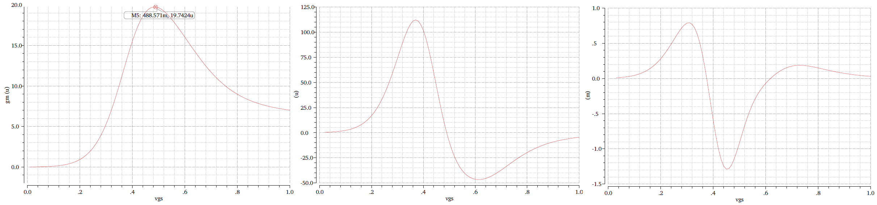
(a) (b) (c)

Fig. 9. (a) g_{m}, (b) its 2nd derivative, & (c) its 3rd derivative curves for the NMOS transistor

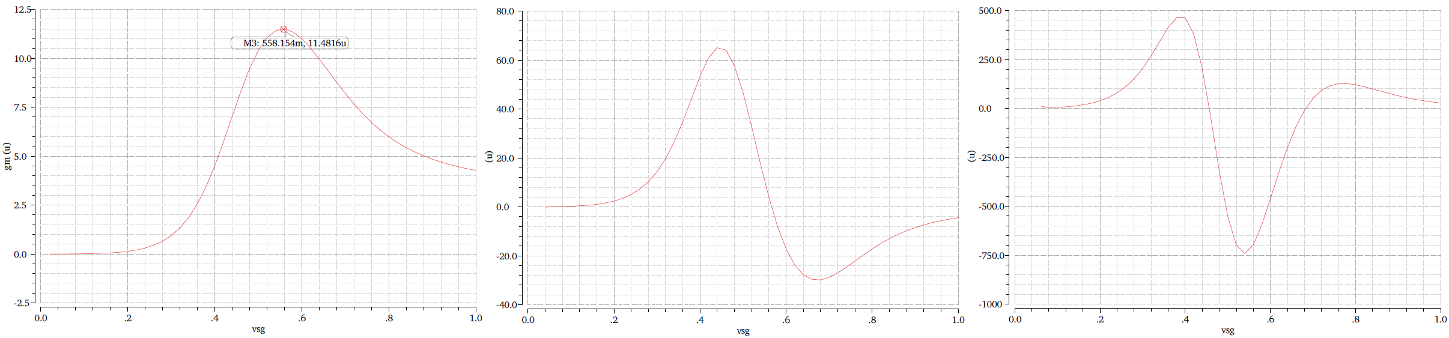
(a) (b) (c)

Fig. 10. (a) g_{m}, (b) its 2nd derivative, & (c) its 3rd derivative curves for the PMOS transistor

Parametric Analysis
The parametric analysis is a useful tool to observe the characteristic curves while changing two variables at the same time. Almost the same steps are conducted as before but at different values of a second variable.
The results will be similar curves to the ones obtained before in the DC analysis, but now there is a curve for each

value of the second variable, all appended to the same graph window for the purpose of comparison & observation.
In the following subsections, a variable that was fixed in one of the previous analyses will be swept over a number of values. The number of steps is chosen such that the simulation would not consume a lot of time.

Drain Current curves
The I_{D}-V_{GS} curve is obtained as before, but with also sweeping V_{DS} with an increment of 100mV, as shown in Fig. 11 & 12. It is shown that the I_{D}-V_{GS} curve is raised as the value of V_{DS} increases, which means a higher V_{DS} results in greater I_{D} to flow at any V_{DS}.
The same goes for the I_{D}-V_{DS} curve, but this time V_{GS} is swept with an increment of 100mV, as shown in Fig. 13 & 14. The I_{D}-V_{DS} curves are raised as the value of V_{GS} increases, because V_{GS} is responsible for the channel formation, so higher V_{GS} gives greater channel.

Output Resistance r_{ds}
Using equation (1) in the ADE calculator, the r_{ds} curve is obtained for different values of V_{GS} with a step of 100mV, as shown in Fig. 15(a) for NMOS & Fig. 16(a) for PMOS. The curves of the second & the third derivatives of I_{D} with respect to V_{DS} are also obtained at these V_{GS} values.
The curves for r_{ds} are drawn on a semi-log scale because the values of r_{ds} could vary from a few Kilo-ohms to Mega-ohms. That’s because when the values of the V_{GS} are very low, the transistor is in the cutoff region or near it, where there is almost no channel for the current to flow. As V_{GS} increases, a channel starts to form, allowing the flow of current, thus represented by lower values of r_{ds}.

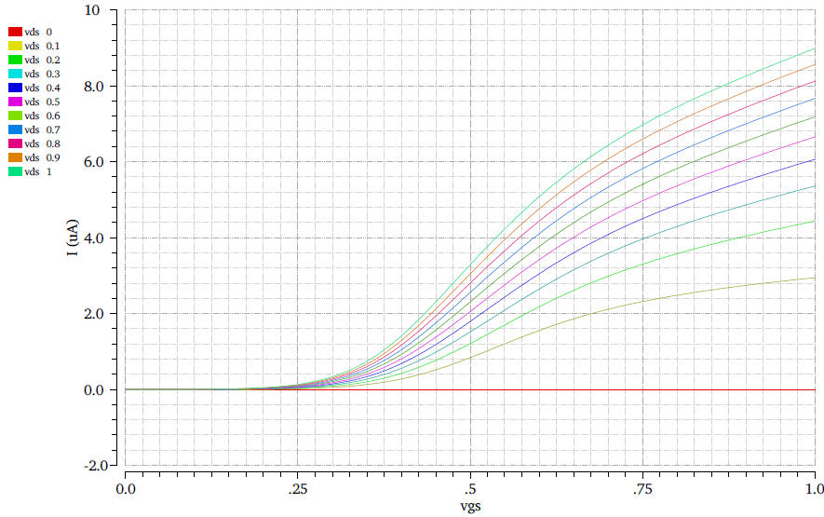
Fig. 11. I_{D}-V_{GS} curves at different V_{DS} values for the NMOS transistor

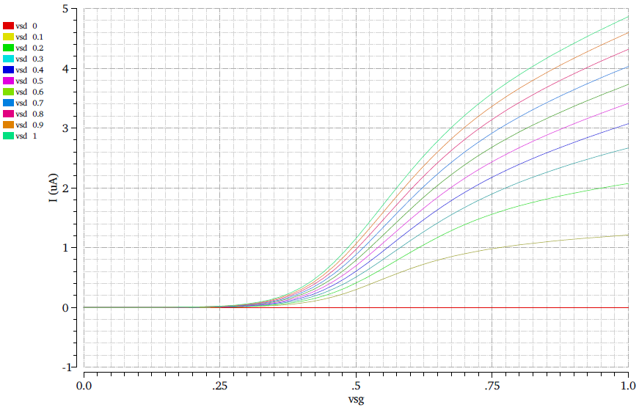
Fig. 12. I_{D}-V_{SG} curves at different V_{SD} values for the PMOS transistor

Transconductance g_{m}
Similar to what was done for the r_{ds} curves, the curves for g_{m}, the second & the third derivatives of I_{D} with respect to V_{GS} are obtained at the different values of V_{DS}. The curves are shown in Fig. 17(a), (b), & (c) for NMOS, and 18(a) (b), & (c) for PMOS.
As seen in Fig. 11 & 12, having a greater V_{DS} results in a greater I_{D} flowing in the channel for the whole V_{GS} range. So, when observing the curves of g_{m} in 17(a) for NMOS & 18(a) for PMOS, increasing the V_{DS} causes an increase for g_{m} at any V_{GS}.

Conclusion
This document presented the behavior of the drain current, I_{D}, with respect to the terminal voltages, V_{GS} & V_{DS}, for the Nanowire SGFET transistors. The curves for the drain-source resistance, r_{ds}, & the transconductance, g_{m}, are also presented, along with the second & third derivatives of I_{D} with respect to V_{GS} & V_{DS}.
These curves & parameters are essential for the building, the designing & the analysis of any analog integrated circuit that will utilize the Nanowire SGFET technology.
The steps of how these curves were obtained using the Cadence Virtuoso Analog Design Environment & its different tools were also explicitly explained so they would be the basis for future circuit design work.

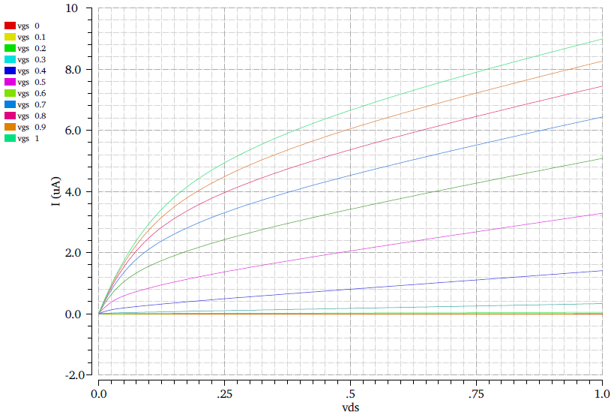
Fig. 13. I_{D}-V_{DS} curves at different V_{GS} values for the NMOS transistor

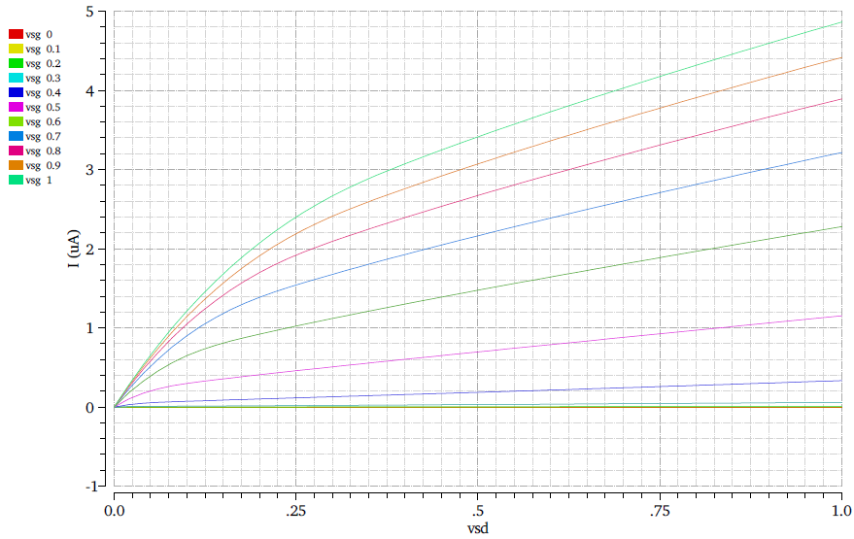
Fig. 14. I_{D}-V_{SD} curves at different V_{SG} values for the PMOS transistor

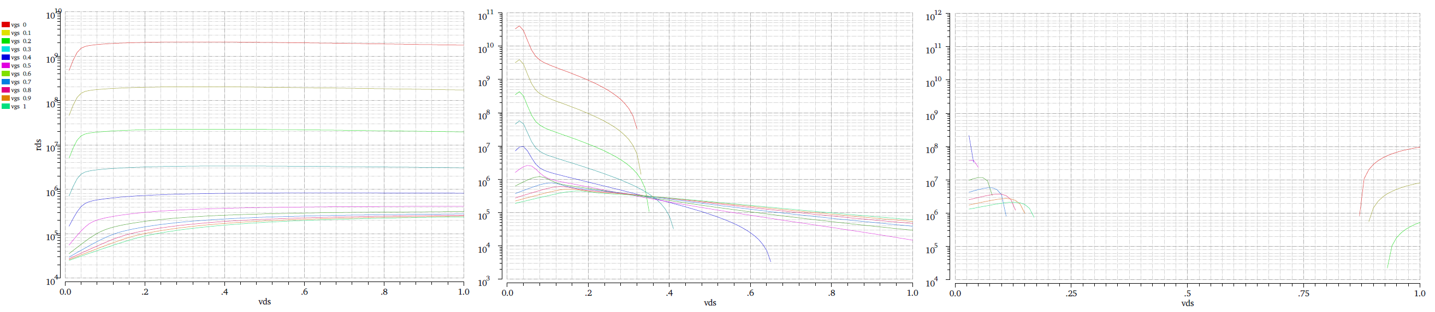
(a) (b) (c)

Fig. 15. (a) r_{ds}, (b) its 2nd derivative, & (c) its 3rd derivative curves at different V_{GS} values for the NMOS transistor

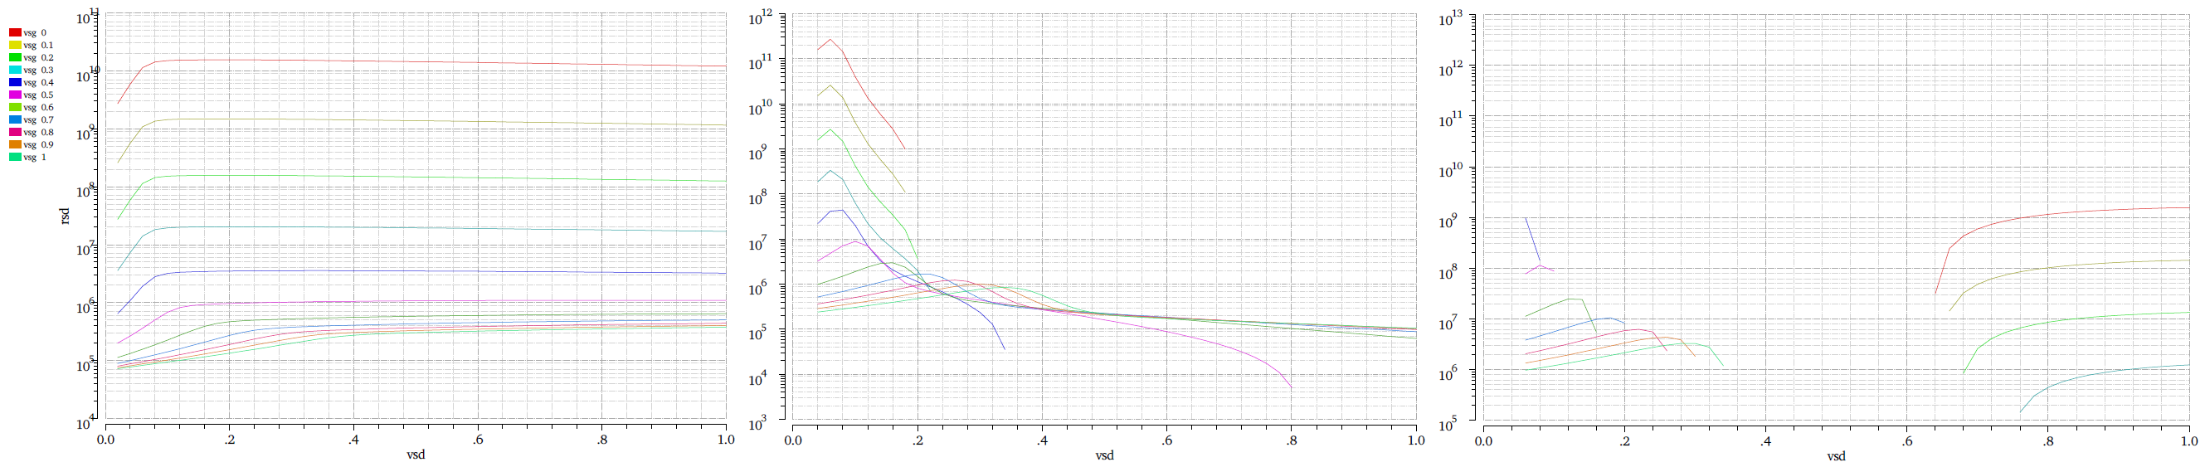
(a) (b) (c)

Fig. 16. (a) r_{sd}, (b) its 2nd derivative, & (c) its 3rd derivative curves at different V_{SG} values for the PMOS transistor

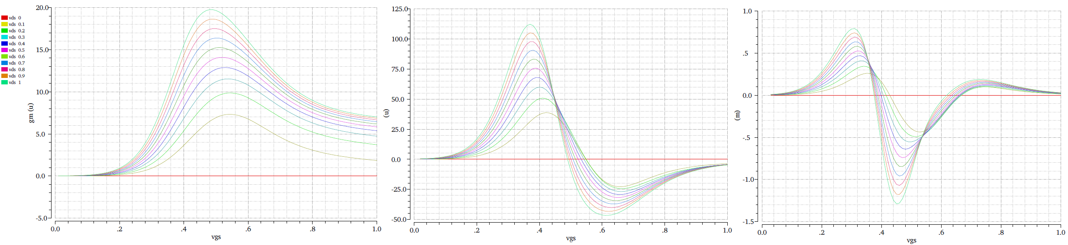
(a) (b) (c)

Fig. 17. (a) g_{m}, (b) its 2nd derivative, & (c) its 3rd derivative curves at different V_{DS} values for the NMOS transistor

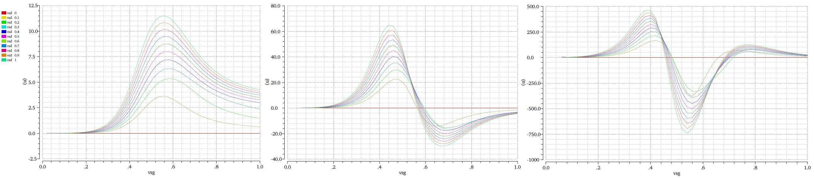
(a) (b) (c)

Fig. 18. (a) g_{m}, (b) its 2nd derivative, & (c) its 3rd derivative curves at different V_{SD} values for the PMOS transistor

References
- B. Razavi, “Design of Analog CMOS Integrated Circuits”, Chapter 2, Boston: McGraw-Hill, 2001.
- S. Hamedi-Hagh and A. Bindal, “Spice Modeling of Silicon Nanowire Field-Effect Transistors for High-Speed Analog Integrated Circuits,” IEEE Transactions On Nanotechnology, Vol. 7, No. 6, November 2008.

